6A^{th} Grade: Unit 6, Lesson 9

- What is the sign of the product based on the visual model shown.
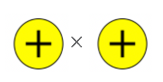
Positive

- What is the sign of the product of -5 x -2?

Positive

- Describe what occurs in an integer chip model that represents 4(-5).

4 groups of -5 are removed and the integer chip model will need 4 zero pairs.

- A number line model of removing 2 groups of 5 is shown. Draw an integer chip model that is equivalent to the number line model.
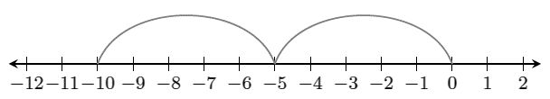
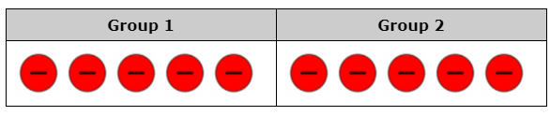

- Create a number line model that represents 2 x (-4) and 2 x 4.
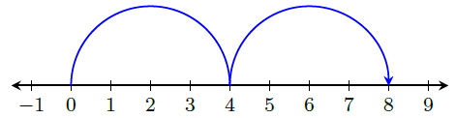

- What does the number line shown represent?
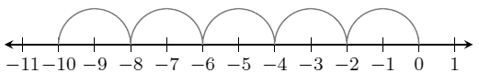
Removing 5 groups of 2

